Exercise 8 : Using dom inspector and fire bug

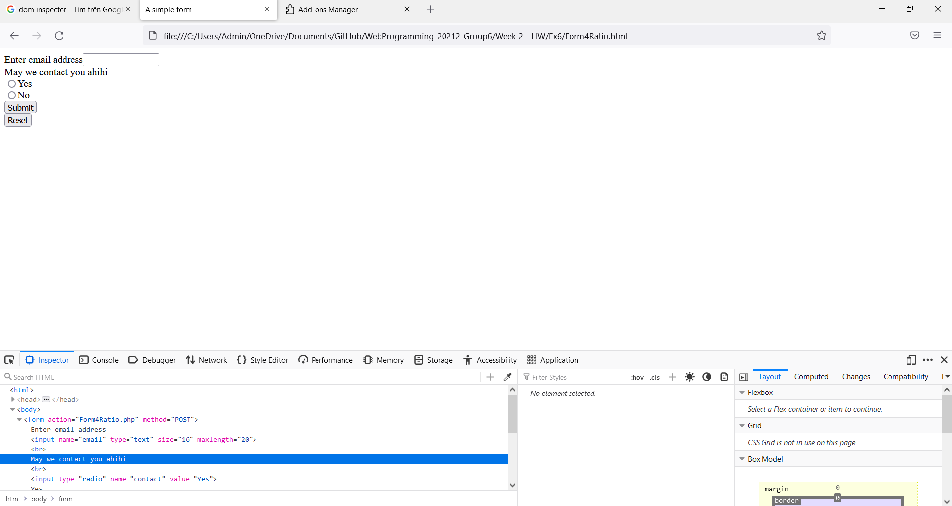

Figure : Using dom inspectoer to change html

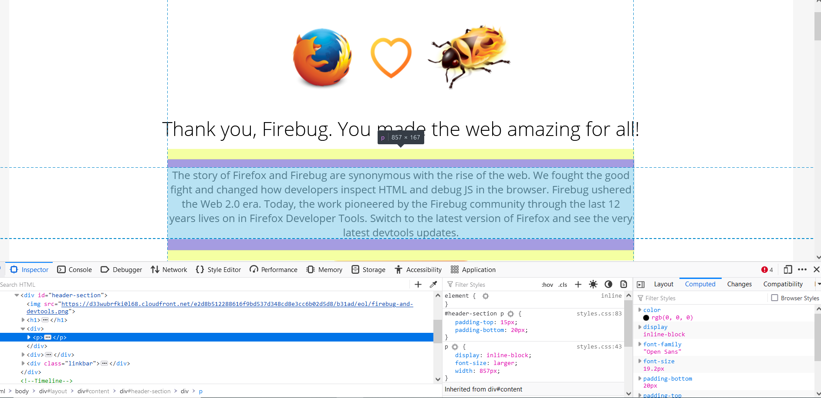

Figure : Using firebug to view css